**RFID Door Lock Access Control System Using Arduino**

GROUP 14

CSC 331 – Data management 1

DR. ODUROYE

CALEB UNIVERSITY IMOTA

LAGOS NIGERIA

**ACKNOWLEDGEMENT**

Firstly, we give thanks to almighty God from the bottom of our hearts. We would like to express our sincere gratitude to our Lecturer, Dr. ODUROYE Department of Computer Science who inspired us in every moment, we are thankful to him for his continuous encouragement, kind co-operation, and scholastic guidance all along the project work. He has always been extremely generous with his time, knowledge and ideas and allowed us great freedom in this project. We would like to thank our entire friends and group members for cooperating to make this successful and for sharing knowledge; information and helping us in making this project a success. And also thanks for lending us some tools and equipment. Finally we would like to thank our parents who have given us tremendous inspirations and supports. Without their mental and financial supports, we would not able to complete our project.

Thanks to all

**Abstract**

This is an RFID-based door locking gadget. This door lock system will give access to only those people who have the registered key card. It uses a servo motor that operates with the help of Arduino. The Arduino board runs with complete programming that is stored inside it. By using this gadget, an owner can give permission to a specific set of people in a particular area. It is also very secure. RFID Module, LCD Display, servo motor and Arduino have also been used in this door lock system. When the door is locked, the LCD displays “PUT IN A CARD” and when the door is open, the LCD displays “DOOR IS UNLOCKED”. The LCD would also display ACCESS DENIED when you scan an unauthorized card.

**INTRODUCTION**

This gadget was designed with the help of an Arduino using a servo motor that pushes the gear in the lock forward and back. When we scan a registered card, it takes instructions from the program and starts a loop in which the servo motor rotates 90 degrees, then the gear mechanism in it works, which locks and opens the door. In other words, when a card is scanned, the condition given in the programming matches, then the command given in that condition becomes active, such that when the correct card is scanned, the open condition will match, in which the servo motor will rotate 90 degrees and the door is open otherwise the door will remain locked and the LCD will display ACCESS DENIED. In this program the servo motor will return back to its original position after 6 seconds i.e., the door is automatically locked after 6 seconds.

This system is normally used in hostels, schools, banks and large companies for security purposes because reliable.

Here are the materials used in this project:

* Arduino UNO x 1
* RFID module x 1
* Jumper Wires
* board
* LCD display x 1
* I2C module x 1
* Servo motor x 1
* Iron stick
* glue
* tape
* door lock

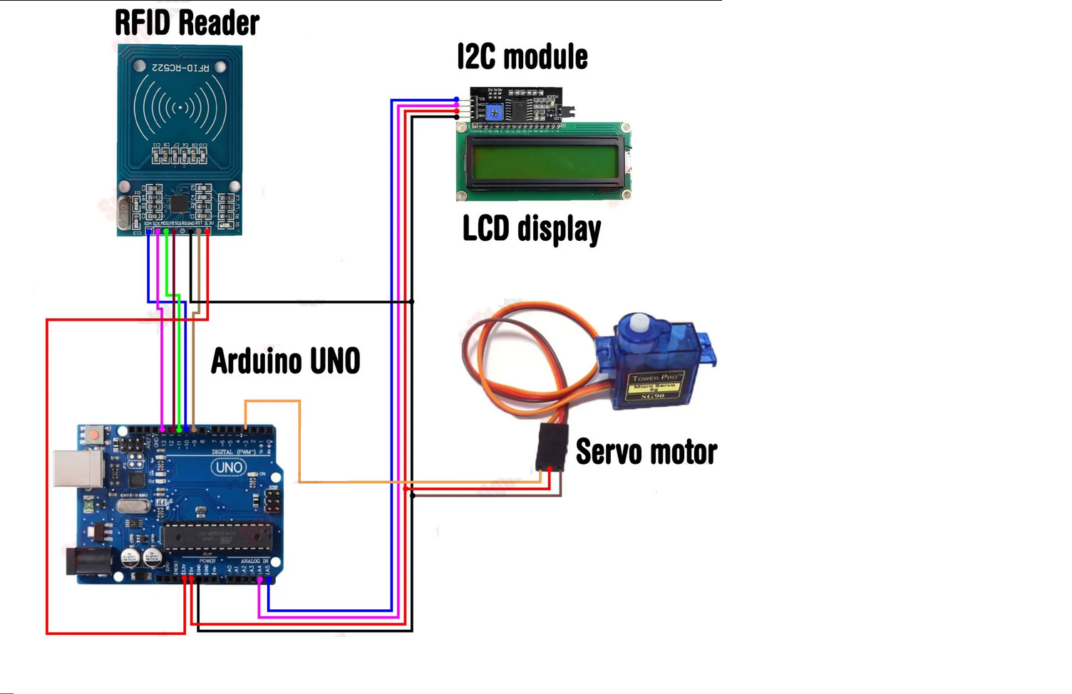

**Fig 1.0 Connection diagram**

The circuit of this project uses four different parts, namely a RFID reader, a controller (Arduino), a servo motor and LCD display as shown in Fig 1.0 above. In this circuit, a reader reads the RFID tags/key cards, a controller is used to accept the data from the RFID reader and control the output of the door lock and LCD.

**Working Method**

Firstly, I2C, SPI, and RFID libraries are included. the door lock system will start when turned on, and the scanning process starts on default, then the LCD displays “PUT IN YOUR CARD”, if the card is registered previously then the command will proceed to open the door and the status of the LCD display is changed to “DOOR IS UNLOCKED”, otherwise if the non-registered card is scanned the LCD displays “ACCESS DENIED. When the door lock is open, the door automatically locks after 6 seconds and the command will run again and the scanning process starts, but now the door lock will be closed.

In order to add another card you simply connect the Arduino to the computer and the scan the card then the UID tag is shown on the seral monitor, you just copy it and put it in the if statement inside the code then upload the updated code.

To delete you can simply just delete the UID tag from the if statement then upload the updated code.

The flow chart below shows a detailed explanation.

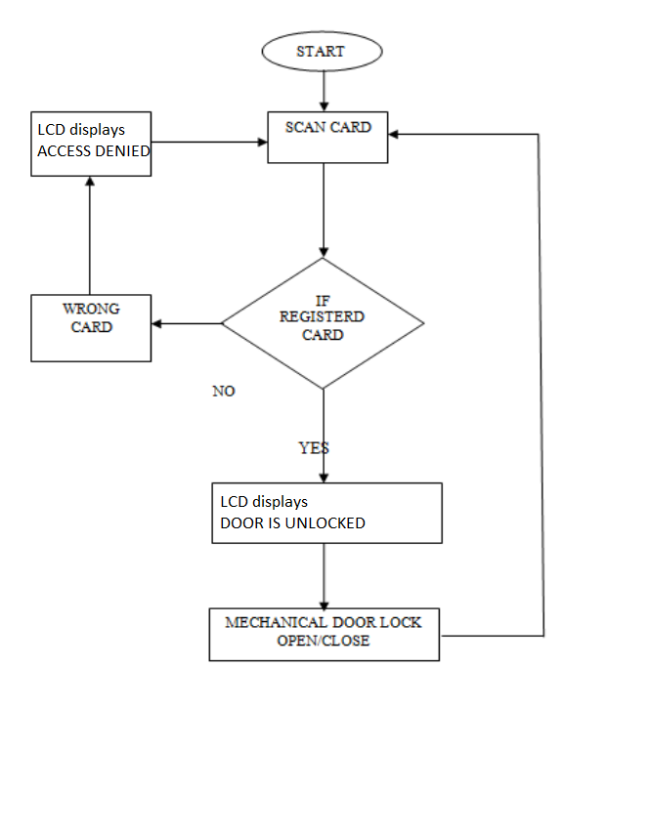

**Fig 2.0**

**Problems encountered**

Few of the problems encountered was getting the materials in hand, because we didn’t have a reliable source to get all the required materials it slowed us down, but we eventually got a place to get all the required materials after discussing with our colleagues who also had the same problem. I guess a problem shared is a problem solved after all.

Another problem we encountered was that the MFRC522(RFID reader) was not reading the key card it kept bringing the error “check your connection”, so we checked and saw that there was nothing wrong with it then after few hours of reasoning we realized that we didn’t install the MFRC522 library on the computer used in programming the Arduino. So, we installed the **MFRC522 BY GITHUB COMMUNITY,** although this didn’t solve our problem but it was something that needed to be done as well, so what solved our problem? you may ask, it turns out that the jumper wired used in this project was rusted and as we all know rust is an insulator thus it does not allow electricity flow through it and that was the reason why the reader couldn’t read the cards. So, we scratched off the rust off every single jumper wire with a razor blade and then used alcohol wipes to wipe it off, and there you go problem solved.

Another issue was with our LCD display, we needed to solder our LCD display to the I2C module but none of our group members had experience on how to solder so it was an issue, how we solved this was that when we went to get the materials, we paid people in the market with experience on how to solder to help us with it and it was done within few minutes. But after this was done our LCD wasn’t displaying what we needed it to display instead it was a blank screen, so we tried to learn from our first problem and install a library, so we went ahead to install LIQUIDCRYSTAL I2C BY FRANK DE BRABANDER. And this was indeed needed but didn’t solve our problem. We solved our problem by adjusting the potentiometer on the I2C as shown in fig 3.0.

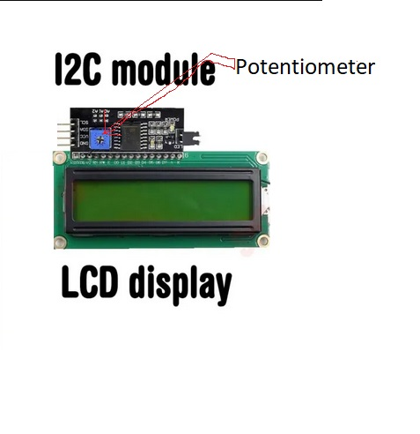

**Fig 3.0**

**Name of Contributors**

* Hosea-Ramon Fortune
* Agbeniga Al-ameen Temitope
* Abu David Idris
* Ogunlaja iseoluwa azeezat
* nwadike david
* EKWEGBALU NNAMDI EBUBE
* Joshua Ayomide
* Ezekwe Ifunanya
* Ejeh Veronica ehi
* Delight Eze-Roberts
* Babatunde Sultan
* Yahaya Abdulsamad Olalekan
* OMOSHOLA BUNMI OSHUNLETI
* Fagbelu Stephen Oluwanifemi
* Bello oreoluwa quam

**REFRENCES**

* <https://github.com/miguelbalboa/rfid>
* <https://stackoverflow.com/questions/40443839/rfid-rc522-not-reading-card>
* <https://www.arduinolibraries.info/libraries/liquid-crystal-i2-c>
* <https://srituhobby.com>
* <https://docs.arduino.cc/learn/starting-guide/the-arduino-software-ide>